**The Sword:**

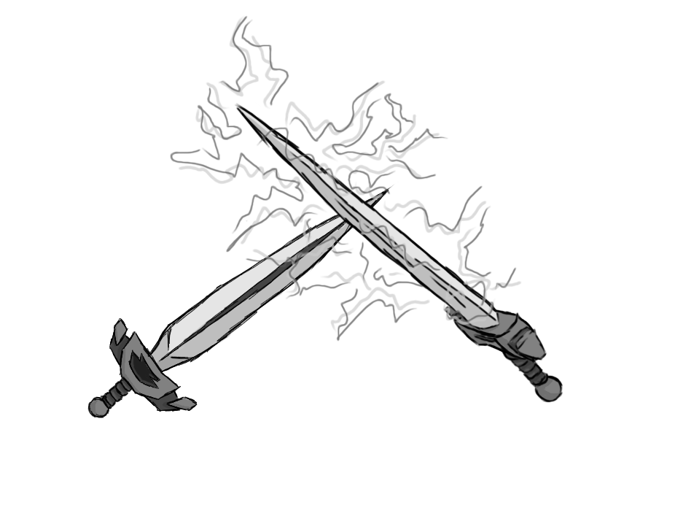

Figure 1 - Weapon: Sword

**Brief Synopsis**

The sword could be considered the base weapon of the game and as such the player will start games with it. The sword is infused with lightning, this makes it have a reliable high damage output and simple use cases. When facing tough enemies that some other weapons might pose a challenge to deal with, the sword is always a good choice to switch too.

**Special Ability**

**Double Jump:  
 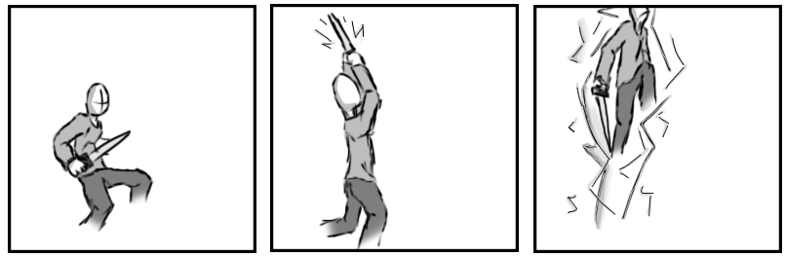**

Figure 2 - Animation Storyboard: Double Jump

**Special:** The player will pull out the sword and point it towards the sky, summoning a bolt of lightning. Channelling the lightning through them and letting it crash onto the ground will cause the player to bolt upwards as if jumping for a second time in the air.

**Combat Ability’s**

**Slash:**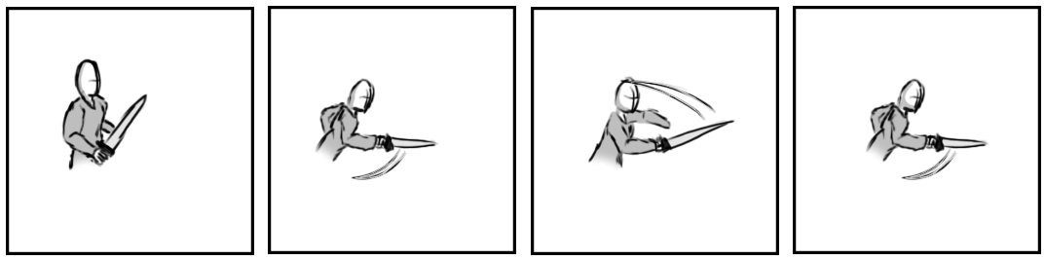

Figure 3 - Animation Storyboard: Slash

**While grounded and stationary:** The player does up to three slashes from side to side. Attacking in front of them in quick succession.

**Sliding slash:**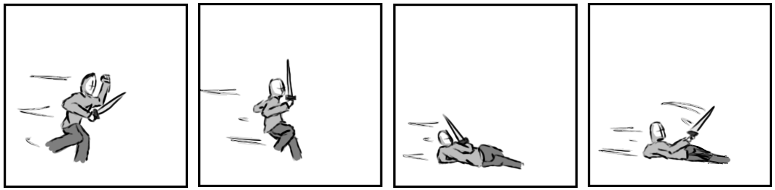

Figure 4 - Animation Storyboard: Sliding slash

**While grounded and in motion**: The player drops to the ground and begins a short slide. After hitting the floor, they will swing the sword in front of them angled slightly up. They could then break from the slide and go straight back to running.

**Thunder strike:**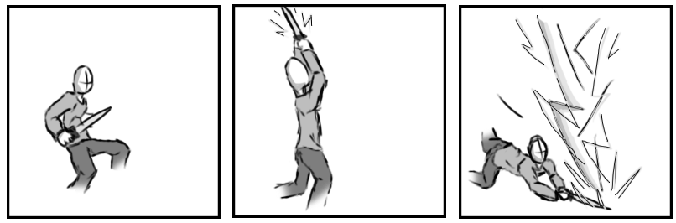

Figure 5 - Animation Storyboard: Thunder strike

**While aerial:** The player aims there sword skyward and summon a bolt of lightning from the sky. There sword will carry the bolt violently to the ground, releasing the energy to the enemies around them, intern dealing huge amounts of damage.